**CALL DATA CENTRE DEMONSTRATION USING OSPF**

A COURSE PROJECT REPORT

By

**KUMAR SHASHWAT (RA2011003011262)**

**ARYAMAN ADIVYA SINGH (RA2011003011266)**

**MOHAMMED SHOAIB KHAN (RA2011003011289)**

**NIPURN BHAAL (RA2011003011272)**

Under the guidance of   
**Mr. S. Saminathan***In partial fulfillment for the Course*

18CSC302J - COMPUTER NETWORKS

in the Department the of Computing Technologies



**FACULTY OF ENGINEERING AND TECHNOLOGY**

**SRM INSTITUTE OF SCIENCE AND TECHNOLOGY**

**Kattankulathur, Chengalpattu District**

NOVEMBER 2022

**SRM INSTITUTE OF SCIENCE AND TECHNOLOGY**

**(Under Section 3 of UGC Act, 1956)**

**BONAFIDE CERTIFICATE**

Certified that this mini project report "**CALL DATA CENTRE DEMONSTRATION USING OSPF**" is the bonafide work of **KUMAR SHASHWAT (RA2011003011262), ARYAMAN ADIVYA SINGH (RA2011003011266), MOHAMMED SHOAIB KHAN (RA2011003011289)** and **NIPURN BHAAL (RA2011003011272)** who carried out the project work under my supervision.

# SIGNATURE

**S. Saminathan**

# Assistant Professor

Department of C.Tech.

SRM Institute of Science and Technology

**ABSTRACT**

This project briefly explains the concept of OSPF protocol and shows its implementation with a use case scenario. Here the scenario is communication and transmission of data, within the branches of a call center. It also illustrates OSPF protocol’s benefits and possible (if any) issues.

The OSPF Protocol is a dynamic routing protocol which provides a highly functional open protocol that any vendor can use to communicate using the TCP/IP protocol family. It can converge the networks extremely fast and ensures loop free paths. It has features that allow for the stricter propagation of routes, for load sharing, and for selective route importing. It can also provide better load sharing on external links rather than other IGPs (Internal Gateway Protocols).

Call Centre Use Case uses a loop free path for faster communication within the department. Open Short Path First allows the imposition of policies for the propagation of routes in the network. This enables the use case to demonstrate a better version of load sharing on external links compared to other IGPs. It is thus widely scalable and can be used for future improvements.

# ACKNOWLEDGEMENT

We express our heartfelt thanks to our honorable **Vice Chancellor, Dr. C. Muthamizhchelvan**, for being the beacon in all our endeavors.

We would like to express our warmth of gratitude to our **Registrar, Dr. S. Ponnusamy,** for his encouragement

We express our profound gratitude to our **Dean (College of Engineering and Technology), Dr. T. V. Gopal,** for bringing out novelty in all executions.

We would like to express our heartfelt thanks to **Chairperson, School of Computing**, **Dr. Revathi Venkataraman,** for imparting confidence to complete our course project.

We extend our gratitude to our **HoD,** **Dr. M. Pushpalatha, Professor and Head, Department of Computing Technologies** and our Departmental faculty members for their Support.

We wish to express our sincere thanks to **Course Audit Professor, Dr. Annapurani Panaiyappan, Professor and Head, Department of Networking and Communications** and the **Course Coordinators** for their constant encouragement and support.

We are highly thankful to our Course project Faculty mentor, **Mr. S. Saminathan, Assistant Professor, Department of C.Tech,** for his assistance, timely suggestion and guidance throughout the duration of this course project.

Finally, we thank our parents and friends near and dear ones who directly and indirectly contributed to the successful completion of our project. Above all, we thank the almighty for showering his blessings on us to complete our Course project.

**TABLE OF CONTENTS**

| **SL. NO.** | **CHAPTER HEADING** | PAGE NO. |
| --- | --- | --- |
| 1. | ABSTRACT | 3 |
| 2. | ACKNOWLEDGEMENT | 4 |
| 3. | INTRODUCTION | 6 |
| 4. | ROUTING TABLES | 7 |
| 5. | DESIGN IMPLEMENTATION | 8 |
| 6. | TESTING and ANALYSIS | 9 |
| 7. | CONCLUSIONS & FUTURE ENHANCEMENT | 14 |
| 8. | REFERENCES | 15 |

**INTRODUCTION**

OSPF (Open Shortest Path First) Protocol is a famous TCP/IP Internal Gateway Protocol which is used to distribute information within a single system. It is based on link-state technology which is different from algorithms like RIPv4 which are used in Internet Routing protocols.

OSPF Protocol has many new features, including:

- Variable Length Subnet Masks

- Route summarization

- Authentication of Routing Updates, etc.

- It uses IP multicast to send link-state updates. This ensures less processing on routers that are not meant to listen to the packets. This in only done in case of a change instead of doing it periodically. This helps in a better use of bandwidth

The traditionally used RIP has various limits in a large network setting which have paved the way for OSPF.



| **Name of call center branch** | **Router**  **number** | **Starting**  **address** | **Broadcast**  **address** | **Subnet mask** |
| --- | --- | --- | --- | --- |
| Dotcom | R0 | 192.168.10.0 | 192.168.10.5 | 28 |
| Dot2com | R1 | 192.168.10.16 | 192.168.10.31 | 28 |
| Dot3com | R2 | 192.168.10.32 | 192.168.10.47 | 28 |

| **From Router** | **To Router** | **Network ID** |
| --- | --- | --- |
| Router 0 | Router 1 | 10.0.0.0 |
| Router 1 | Router 2 | 11.0.0.0 |
| Router 2 | Router 0 | 12.0.0.0 |
| Router 1 | Router 3 | 13.0.0.0 |
| Router 2 | Router 4 | 14.0.0.0 |
| Router 3 | Router 5 | 15.0.0.0 |
| Router 4 | Router 6 | 16.0.0.0 |
| Router 5 | Router 7 | 17.0.0.0 |
| Router 6 | Router 8 | 18.0.0.0 |
| Router 7 | Router 9 | 19.0.0.0 |
| Router 9 | Router 8 | 20.0.0.0 |
| Router 8 | Router 5 | 21.0.0.0 |
| Router 6 | Router 3 | 22.0.0.0 |
| Router 0 | Router 3 | 23.0.0.0 |
| Router 4 | Router 7 | 24.0.0.0 |

**Assignable host address= 14 each**

**DESIGN IMPLEMENTATION**

The following network topological figure drawn in Cisco Packet Tracer applies the use case of Call Centre Data Transmission using OSPF.

The call center implements three main departments that show the implementation of OSPF using live action simulation and two additional departments that show the main servers attached to it.

The criss-cross implementation of routers allows the versatility of adding additional servers and departments to it.

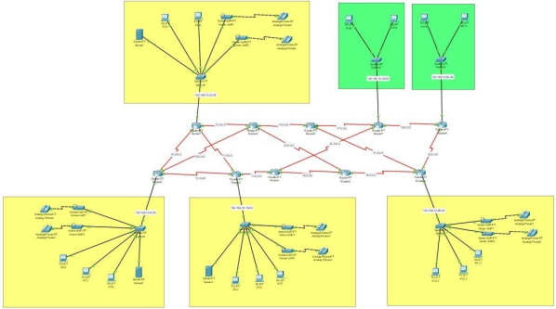

**TESTING and ANALYSIS**

1. The CLI of router 0 shows the internet address with the subnet mask and broadcast address. Assignment of IP addresses is successful.

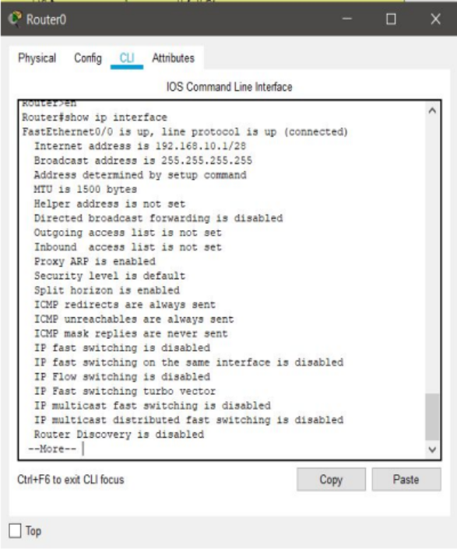

1. 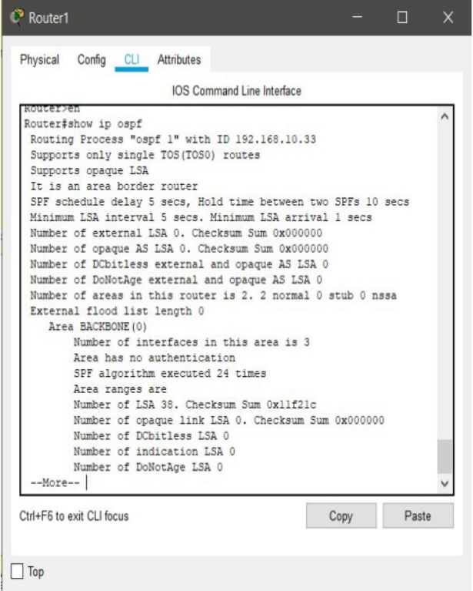The OSPF protocol successfully configured at router 1.
2. Total addresses, IP address range, current index are shown on CLI of router 0. Similarly we can check if the DHCP has been set up or not on other 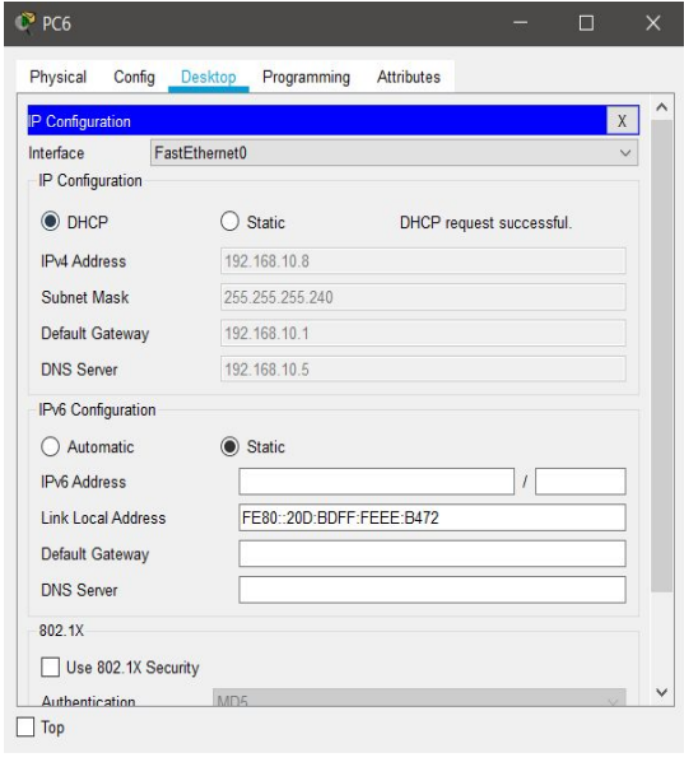routers too. DHCP request on PC0 is successful.
3. Shows the DNS server (192.168.10.5) at zone1 resolving host names into IP addresses.

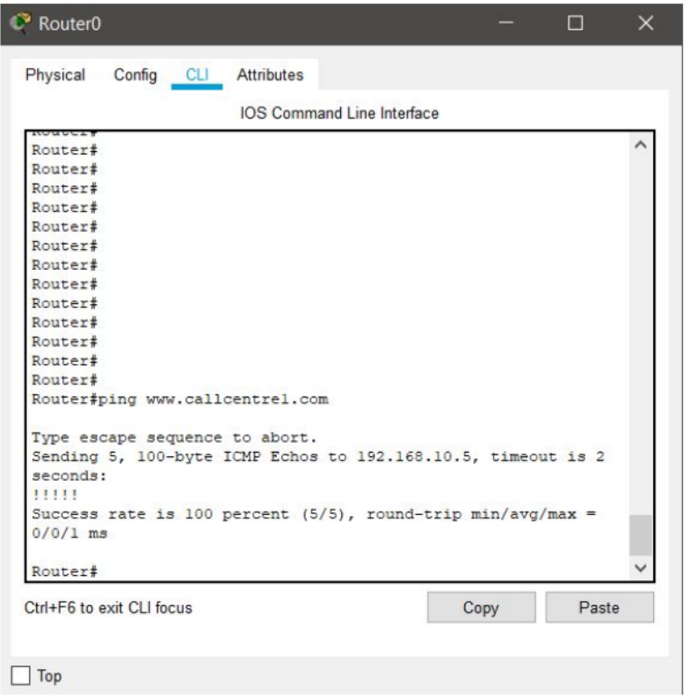

Henceforth, the terminal can also be used to check faster implementations and testing our network by also getting a deep insight of the packets lost and the time it took to achieve the results with the loss percentage.

1. The following message displays the successful pinging of message packets from PC0(192.168.10.6) to PC2(192.168.10.22) and from PC6(192.168.10.8) to PC5(192.168.10.35)

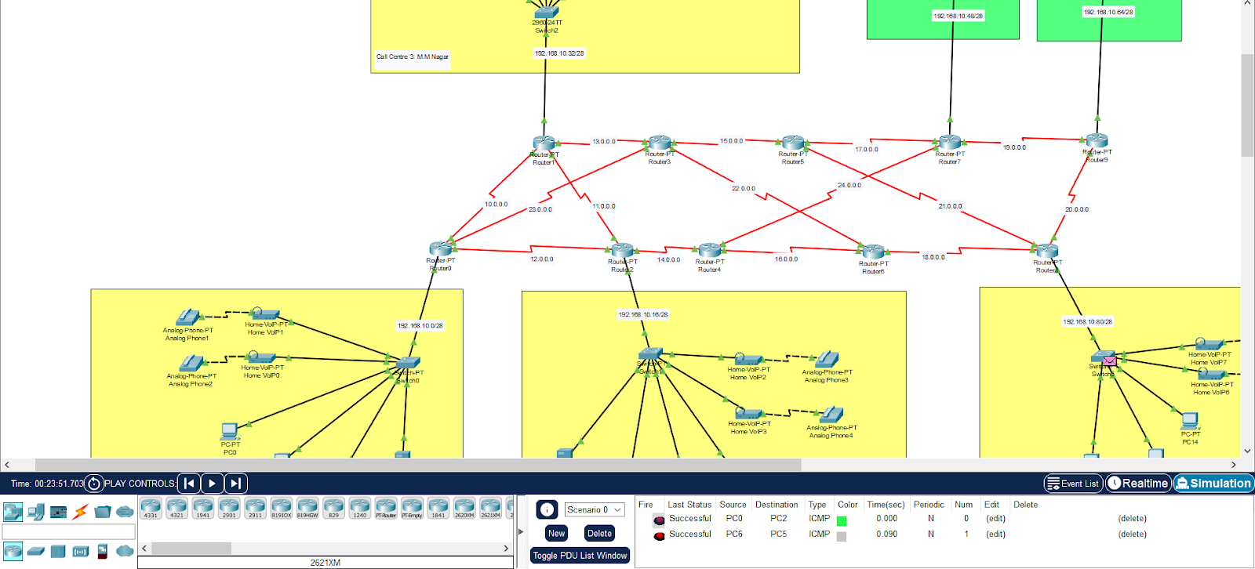

**CONCLUSION and FUTURE ENHANCEMENT**

Multi LAN Fast Communication Network Topology is useful and can be implemented in call centers where quick retrieval of data is needed in order to ensure quick responses to the customers. As we have implemented OSPF Protocol, communication happens faster finding the shortest path for a message sent from a sender to travel and reach the receiver.

**Future Enhancements:**

* For future enhancement of this network scenario, we can implement VPN (Virtual Private Network) tunnel between routers. Hence, when one call center transfers data to another, the data being transferred is always secure and in case of a breach the location cannot be traced.
* 10 routers are available so the number of branches can be increased in order to expand the area covered by the call center.

**REFERENCES**

<https://www.netacad.com/courses/packet-tracer>

<https://www.cisco.com/c/en/us/td/docs/routers/access/800M/software/800MSCG/routconf.htm>

**Subnetting:**

<https://www.cisco.com/c/en/us/support/docs/ip/routing-information-protocol-rip/13788-3.html>

**OSPF Protocol Configuration:**

[https://www.cisco.com/c/en/us/td/docs/ios-xml/ios/iproute_ospf/configuration/xe-16/iro-xe-16-book/i ro-cfg.html](https://www.cisco.com/c/en/us/td/docs/ios-xml/ios/iproute_ospf/configuration/xe-16/iro-xe-16-book/i%20ro-cfg.html)